**Time of flash**: [Light on] 0–0.2s: This is the latency period during which the pupil does not yet respond. The exact latency depends on many factors, such as stimulus intensity (latencies decrease with stimulus intensity) and age (latencies increase with age) ([Ellis, 1981](https://www.ncbi.nlm.nih.gov/pmc/articles/PMC6634360/#B31)).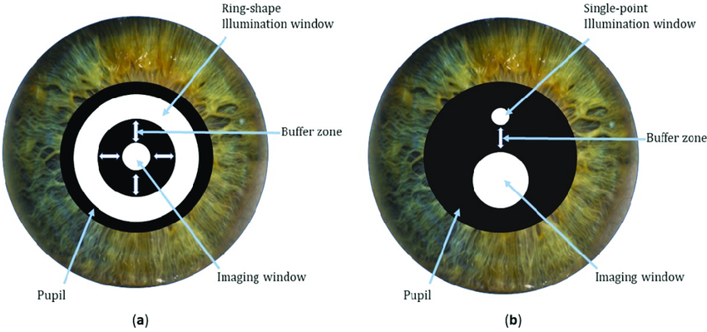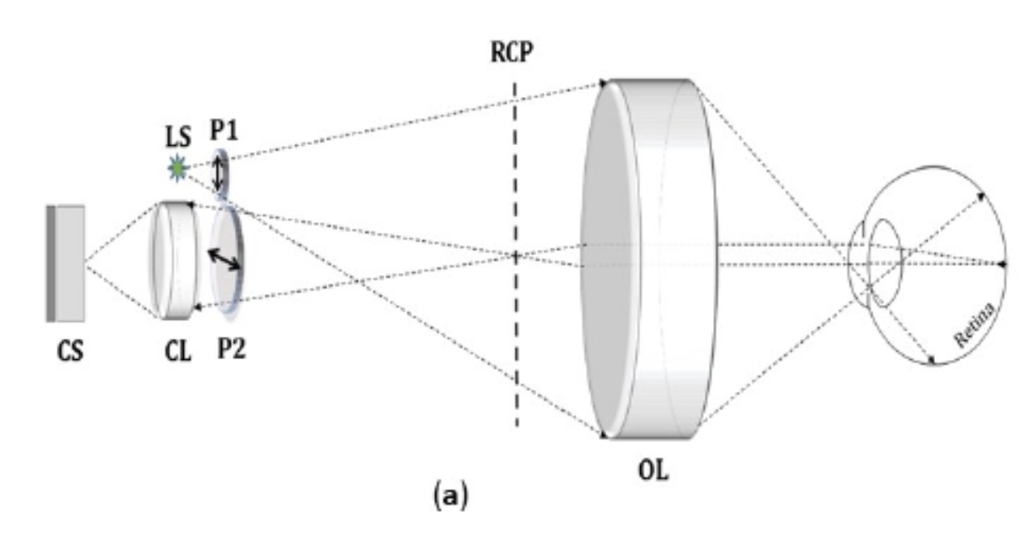

Theoretically only need one light source as in diagram above (this will decrease cost and complexity of design). **Indirect illumination**.

**Light Limitations based on health hazards:**

$t_{max} = \frac{max allowed weighted irradiance}{calculated weighted irradiance}$ where max exposure time is 46.3 hours